# Lab 07_01 -- Chapter 07 – Western GPA Calculator

## Lab Description:

This week you are going to use your knowledge of arrays to create a Java class that will calculate your cumulative grade at Western. See the attached spreadsheet called Western_GPA_Example.xlsx, if you need a refresher on how GPA is determined.

I have provided a stubbed out class called WesternGPACalculator.java. A stubbed out class simply means the flow of the program has been provided, but the details remain to be done. You job is to provide the code that will actually calculate the cumulative GPA.

Here is a sample of the output using Western’s sample numbers once that class is complete…

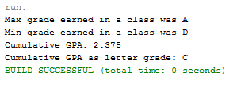

Your output format should match the above sample.

## Lab Requirements:

1. Download and review Western_GPA_Example.xlsx from Blackboard
2. Download WesternGPACalculator.java from Blackboard
3. Review the stubbed out code in WesternGPACalculator.java before you start coding
   1. Let me know if you have questions.
4. Finish WesterGPACalculator.java by providing working code to each “TODO” comment in the code
5. Use Java formatting conventions
6. Use comments where appropriate
7. Test your program using the samples provided to validate your program.
8. Submit your source code
   1. Remember, your submitted source code must compile or a zero will be given